**Santosh MuniswamyGowda Nagaraja  
Pavan Kumar**

**Project feed the kitty**

**UML Diagrams and Use case diagrams**

**Structural UML diagram:**

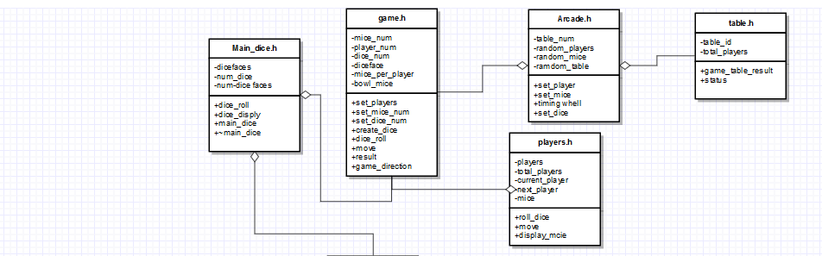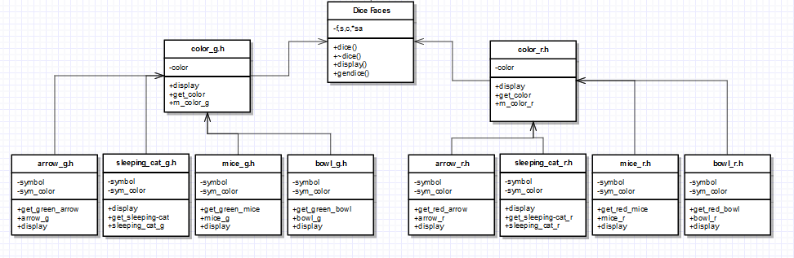

**Use case diagrams**

